**SOFTWARE DEVELOPMENT PROPOSAL**

**Admirable-ty**

**PREPARED FOR**

***Back Alley Front Company, Inc.***

**PREPARED BY**

**Miguel Palima**

**Olivia Sirak**



|  |  |  |  |
| --- | --- | --- | --- |
| **PROJECT NAME** | Admirable-ty | | |
| **EST. START DATE** | 3 August 2020 | **EST. FINISH DATE** | 6 August 2020 |
| **SUBMITTED TO** | *Back Alley Front Company, Inc.* | **COMPANY** | *Back Alley Front Company, Inc.* |
| **CONTACT NAME** | Robin Banks | **ADDRESS** | 24601 Donatella Nobodi Ln  Secret Town, California  95713 |
| **PHONE** | 999-867-5309 |
| **EMAIL** | robin.banks@backalleyfrontco.com |

|  |  |  |  |
| --- | --- | --- | --- |
| **SUBMITTED BY** | Miguel Palima, Olivia Sirak | **COMPANY** | P.S. Development |
| **CONTACT NAME** | Miguel Palima, Olivia Sirak | **ADDRESS** | 999 Mein Herr St  No Name, Colorado  81601 |
| **PHONE** | 888-867-5309 |
| **EMAIL** | devteam@psdevelopment.com |

|  |
| --- |
| **PROJECT OVERVIEW** |
| To create a social-networking app that allows users to rate other users on a 0-5 scale and test their likeability or *admirable-ty*. |
| **PURPOSE / GOALS** |
| To create a system that will enable people to rate and differentiate others based on their likeability rating/designation and to assign weighted average ratings to each user whereby ratings from higher-rated users are given greater weight. |

|  |
| --- |
| **OBSTACLES** |
| -Utilizing previously-unused technologies such as Angular.  -Ensure compatability between technologies.  -Tight deadline. |
| **INDUSTRY / MARKET RISK FACTORS** |
| -Non-adoption of the app by potential users.  -Banning of the app by the app stores of Google, Apple, etc.  -Cancellation of service from infrastructure providers due to updates in their Terms and Conditions of use.  -Acquisition or duplication by nefarious totalitarian states that seek to impose social order. |
| **BUDGETARY RISK FACTORS** |
| Costs should be scalable with app usage. |
| **HARDWARE COMPATIBILITY** |
| The app should be compatible with any web-enabled device. |
| **SOFTWARE EMPLOYED** |
| Angular (front-end), Spring Tools Suite(back-end), AWS Database for MySQL, and Heroku (deployment) |

|  |  |  |  |
| --- | --- | --- | --- |
| **TIMELINE / MILESTONES** | | | |
| **OVERVIEW** | After submission of the project proposal, complete minimum viable product (MVP) for back end, followed by completion of front end for MVP, then adding additional features one-by-one as time permits before deployment. | | |
| **MILESTONE** | | **REPORTING** | **DEADLINE** |
| Project Proposal | |  | EOD, 3 August |
| Complete backend for Minimum Viable Product | |  | 2pm, 4 August |
| Complete front end for MVP | |  | Noon, 5 August |
| Add additional features like hidden ratings for users unrated by viewer | |  | 3pm, 6 August |
| Deploy | |  | EOD, 6 August |
|  | |  |  |
|  | |  |  |
|  | |  |  |
|  | |  |  |
|  | |  |  |
|  | |  |  |
|  | |  |  |
|  | |  |  |
|  | |  |  |
|  | |  |  |
|  | |  |  |
|  | |  |  |
|  | |  |  |
|  | |  |  |
|  | |  |  |
|  | |  |  |
|  | |  |  |
|  | |  |  |

|  |  |  |  |  |
| --- | --- | --- | --- | --- |
| **DEPLOYMENT / DISTRIBUTION** | | | | |
| Online availability via web browser. Eventual expansion into Google and Apple app stores for mobile devices. | | | | |
| **TESTING** | | | | |
| Manual testing using dummy accounts, followed by beta testing with a select group of real users. | | | | |
| **DOCUMENTATION** | | | | |
| -Comments written into the code  -UML concept models  -User view mockups. | | | | |
| **SUPPORT** | | | | |
| For support during pre-deployment and initial launch, contact the developers. For real-world use, contact the dedicated support team. | | | | |
| **TRAINING** | | | | |
| A 1-page user How-To guide. The app itself should be simple and intuitive to use. | | | | |
|  |  |  |  | |
| **COST STRUCTURE** | | | | |
| **OVERVIEW** | Costs should be variable, scaling with usage. | | | |
| **NEEDS / INVESTMENT** | | | | **COST** |
| Heroku app hosting | | | | Free to $500 per month |
| AWS Aurora Database | | | | $0.10 per GB-month plus $0.20 per 1 million requests |
| AWS Aurora Database accessibility - db.t3.small | | | | $243.00 per year if paid upfront |
|  | | | |  |
|  | | | |  |
|  | | | |  |
|  | | | |  |
| **ESTIMATE TOTAL** | | | |  |
| **PAYMENT TERMS** | | | | |
| Costs incurred should be monthly (or annually if discounts on subscriptions are offered). | | | | |

|  |  |
| --- | --- |
| **TERMS & CONDITIONS** | |
|  | |
| **PROPOSAL MAY BE WITHDRAWN IF NOT ACCEPTED BY DATE OF** |  |
|  | |

|  |  |  |  |
| --- | --- | --- | --- |
| **ACCEPTANCE OF PROPOSAL** | | | |
| **AUTHORIZED CLIENT SIGNATURE** |  | **DATE OF ACCEPTANCE** |  |

App Architecture

Features and Priority

Minimal Viable Product:

Pages

* Home page for non- logged-in users (splash page)
* User sign-up – form entry of user’s first name, last name, city, state, country, email, and date of birth √
  + and, Sign-up confirmation page √
* User log-in √
* User pages with name and city
* Search Users Page

Additional Functions

* User log-out √
* Navbar
* Weighted average rating display for each user (profile page) √
* Ability to rate other users √

Additional Features – First Priority:

* Delete logged-in function
* “Admirable-ty” designation based on weighted average rating √
* Weighted average rating weighted heavily towards ratings given by higher-rated users √
* Ensure no more than one rating exists from any one rater to another (users cannot cast two “votes” for each subject user)

Additional Features – Second Priority:

* Anonymous follow (“Track”) and unfollow (“Purge”) function √
* Following page of users that one is following
* Ability to re-rate users that overrides previous rating

Additional Features – Third Priority:

* Logo
* Help page
* User profile photos

- Average rating given by user (user profile)

- Last five ratings given to user (by whom and their info listed) (user profile)

Additional Features – Fourth Priority:

* Last five ratings given by user

Additional Features – Fifth Priority:

* Show dates of the user’s past five ratings given and received
* Show number of followers/trackers on profile page

Additional Features – Sixth Priority:

* Ensure user’s email address is unique before sign-up
* Ensure users are over 16

Additional Features – Final Priority:

* GPS linking to phone to ensure that a user can only rate someone they have met within the past 72 hours
* Snapchat-style QR code on profile page that stores user’s id
* Secret self-destruct function that destroys all ratings records for all users (Order 66)
* Tie city, state, and country fields to API to ensure those entered are real
* Users kicked off the app upon getting a 0.00 weighted average rating
* Ensure users enter their phone number (with country code) upon sign-up to further prevent the creation of duplicate and fake accounts

Possible Future Features:

* Email/phone verification
* Suggested users to rate and/or track based on the users rated and tracked by the logged-in user

Notes on Ratings

* User designations are as follows:
  + 4.5 - 5.0: “Fleet Admirable”
  + 3.5 - 4.49: “Admirable”
  + 2.5 – 3.49: “Vice Admirable”
  + 1.5 – 2.49: “Rear Admirable – Upper Half”
  + 0.5 – 1.49: “Rear Admirable – Lower Half”
  + 0.01 – 0.49: “Swab”
* Weighted average rating is weighted by rater’s rating on an exponential scale:
  + Rating = (sum of all (rater’s weight x stars given))/(sum of all weights))
  + Weight w = 2 ^ user’s rating
  + Examples:
    - 0-star: w =1
    - 0.5-star: w = 1.41
    - 1-star: w =2
    - 2-star: w = 4
    - 3-star: w = 8
    - 3.5-star: w = 11.31
    - 4-star: w =16
    - 4.29-star: w = 19.56
    - 5-star: w = 32
  + So if a User A was rated twice: rated 4 by a 0.2 star user (w=1.1487) 4 and rated 2 from a 4.7-star user (w=25.992):
    - 1.1487(4)+25.992(2)= 57.932 / 27.1407 = 2.1345 = User A’s weighted-average rating
* New users without any ratings assigned (and thus have no average rating) will have an initial rating of 2.0

Front End Pages

* Log-in/Welcome
* Sign-Up
* Edit User Info (link in Help page)
* Delete Account (link in Edit User Info page)
* Profile
* Tracking
* Search
* Help

Back End Java Class and Repository List

com. AdmirabletyApp

* AdmirabletyAppApplication.java

com. AdmirabletyApp.configuration

* SecurityConfiguration.java
* -ThymeleafConfiguration.java
* WebMvcConfiguration.java

com. AdmirabletyApp.controller

* AuthorizationController.java
* TrackingController.java
* UserController.java

com. AdmirabletyApp.model

* User.java
  + Long id, String email, String firstName, String lastName, String username, String password, String city, String state, String country, String active, Date DOB, Double overall_rating (imported from method in UserService), String designation (imported from method in UserService), ArrayList<Rating> ratingsRecieved, Date createdAt, Set<Role> roles, List<User> tracking (imported from Tracking), String nameString (concated from firstName, lastName and username for search purposes)
* Rating.java – ratings given by one user to another
  + Long id, User rater (joined on rater’s user_id), Integer stars_given, Date createdAt
* Role.java
  + Long id, String role;

com. AdmirabletyApp.repository

* UserRepository.java
* RoleRepository.java

com. AdmirabletyApp.service

* UserService.java

Key Words

* Rating: a single instance of one user rating another
  + Rater: user submitting the rating
  + Subject: user who is being rated
* Tracking: a single instance of one user following another
  + Track: to follow
  + Purge: to unfollow
  + Tracker: user who seeks to track (follow) another
  + UserToTrack: user being tracked
  + Tracking: list of users logged-in user is tracking
  + Trackers: list of users tracking logged-in user

UML Diagram

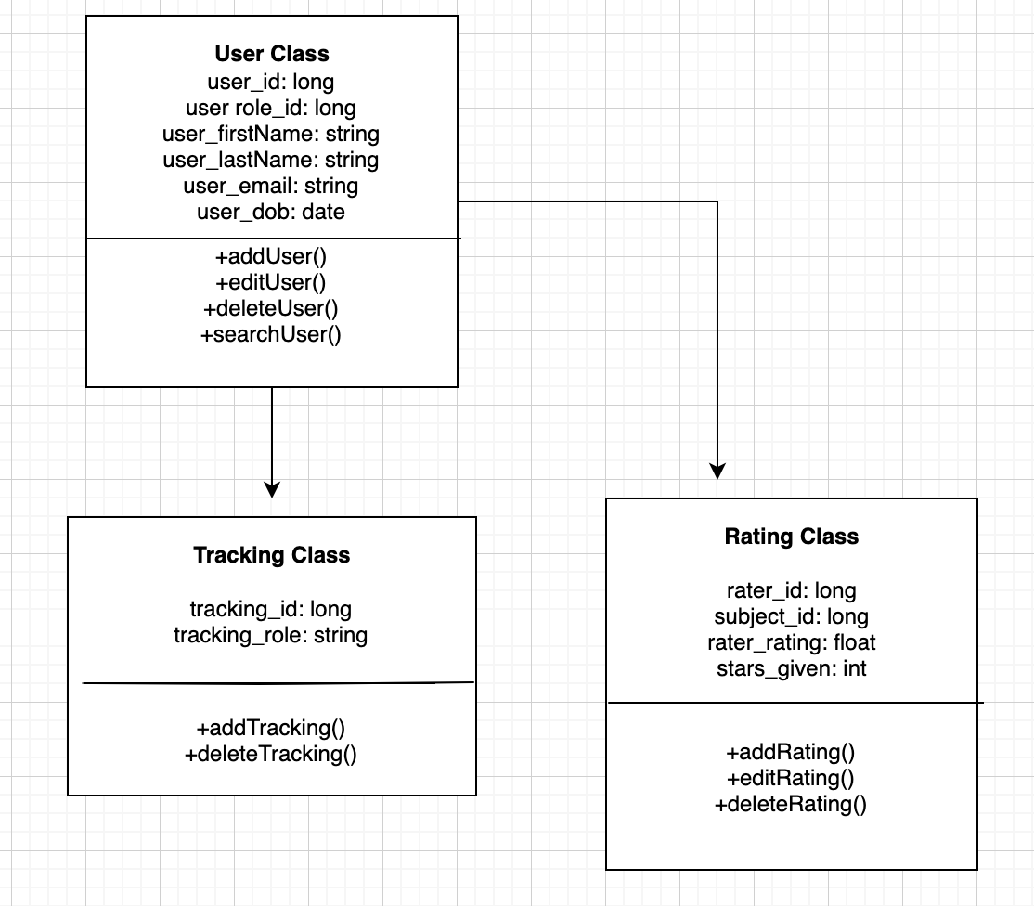

User View Mock-Ups

If a rating has already been given to this user, the logged-in user will see the number of stars he/she has given to this user. Beneath this will be an input similar to the shown “Give Your Own Rating” that will enable edit of that rating.

A user will be able to rate someone that he/she has not rated prior on this page (as well as on the similar “Tracking” and search results pages). To edit a rating, one must navigate to the that person’s profile.

